

Life Cycle Assessment and Redesign Proposal for a Cat Teaser Wand

Module: 6E7Z2148 Engineering Sustainability
Student name: Hussaini Stephen Jacob
Student ID: 24813722
Course: MSc Engineering Project Management
Baseline product: ABS + nylon string
Redesign product: ABS + hemp string

Abstract
This report evaluates the life-cycle environmental and economic performance of a cat teaser wand and develops a lower-impact redesign using Ansys Granta EduPack Eco Audit and supporting literature. The functional unit is one wand produced in a batch of 50,000, with a one-year service life and downcycling at end-of-life. A baseline model (ABS injection-moulded handle with nylon string) was built and compared with a redesign that substitutes hemp fibre cord for the nylon string while retaining the ABS handle to maintain performance and manufacturability. Activities included bill-of-materials and process modelling, life-cycle hotspot identification, comparative impact and cost analysis and a renewable-manufacturing scenario using UK government electricity conversion factors and solar PV cost/load-factor evidence. The redesign reduces first-life energy demand by ~20% and climate-change impact by ~25%, with a small unit cost reduction (~3%) at the stated volume. Impacts are dominated by ABS material production and polymer processing, while the string substitution drives most improvement due to lower embodied energy and greenhouse-gas intensity. A scenario supplying the manufacturing electricity demand with an ~18 kW PV system would materially reduce Scope-2 emissions. The proposal was also appraised for economic feasibility, ethical considerations and health & safety risks. Overall, the ABS + hemp string redesign is recommended as a pragmatic, low-disruption improvement that reduces microplastic risk from synthetic fibres and improves life-cycle performance.

Table of Content
Abstract II
Table of Content III
1. Introduction 1
2. Literature review 3
2.1. Microplastic shedding from synthetic fibres and implications for product design 3
2.2. Policy and sustainability drivers for textiles and plastics 3
2.3. Natural fibres (hemp) as a lower-impact alternative: benefits and constraints 3
2.4. Life-cycle hotspots in low-energy-use consumer products and the role of manufacturing 4
2.5. LCA standards and guidance underpinning a streamlined Eco Audit approach 4
2.6. Circularity and end-of-life: mixed materials, separability and pragmatic redesign 4
2.7. Electricity decarbonisation evidence for manufacturing scenarios 5
2.8. How the review informed this study 5
3. Methodology 6
3.1. Goal, scope and functional unit 6
3.2. Product composition and assumptions 6
3.3. Eco Audit modelling procedure and reported metrics (Ansys Granta EduPack) 7
4. Results and Discussions 8
4.1. Materials selection 8
4.2. Process selection 9
4.2.1. Handle process (ABS) 9
4.2.2. String process (braided hemp cord) 10
4.2.3. Renewable electricity options for lower-emission manufacture 11
4.3. Product life cycle (PLC) 12
4.4. Life Cycle Analysis (Granta EduPack Eco Audit) 13
4.4.1. Eco Audit output (redesign case) 13
4.4.2. Eco Audit phase breakdown (redesign) 14
4.4.3. Baseline vs redesign comparison (ABS + nylon vs ABS + hemp) 15
4.5. Evaluation of proposal (sustainable development feasibility) 17
4.5.1. Economic feasibility and commercial risk 17
4.5.2. Environmental considerations 18
4.5.3. H&S appraisal 19
4.5.4. Ethical considerations 19
5. Conclusions 20
6. References 21
7. Appendices 24
7.1. Appendix A: Eco Audit detailed outputs (redesign case) 24

Introduction
Pet toys are widely manufactured using commodity polymers and synthetic textiles because these materials are inexpensive, readily available and offer consistent durability in everyday use. Cat teaser wands combine a rigid polymer handle with a flexible string or cord that experiences repeated bending, abrasion and occasional chewing. While these choices support product performance, they also raise environmental concerns. During production, normal use, cleaning and disposal, synthetic fibres like nylon and polyester can shed microplastic fragments, which adds to the problem of plastic pollution that won't go away. Also, polymer-based parts often have a lot of embodied energy and greenhouse gas emissions because of the energy-intensive processing and material production that occurs upstream.
At the same time, policy and industry guidance increasingly emphasise improved durability, responsible sourcing and better end-of-life outcomes for plastics and textiles, alongside growing expectations for manufacturers to evidence environmental performance. In this context, life cycle thinking helps us figure out where impacts happen and which changes work best. This assignment uses a simplified life cycle assessment (LCA) method on a typical cat teaser wand to measure its baseline environmental and cost performance and to test a redesign that lowers its impact without making it less safe, usable or easy to make.
Aim: To evaluate the life-cycle environmental and economic performance of a cat teaser wand and develop a practical lower-impact redesign.
Objectives:
Define the standards for the cat teaser wand's product system, functional unit, production volume, service life and end-of-life.
Model a simplified LCA/Eco Audit method (like Ansys Granta EduPack) to model the baseline design and figure out the unit cost, climate change effect and energy demand over the life of the product.
Find the most important parts of the life cycle (like materials, processing, transport and end-of-life) to focus on for big improvements.
Create and evaluate a practical redesign that focuses on replacing the string material while keeping the necessary performance, safety and ease of manufacture.
Compare the results of the baseline and redesign and think about a scenario for supplying electricity (like renewable manufacturing) to see how Scope-2 emissions could be cut.
Appraise the preferred option against economic feasibility, ethical considerations and health & safety risks, leading to a justified recommendation.
Report structure: The second section of the report talks about the product, the system's limits, the assumptions and the way it will be evaluated. In Section 3, presents baseline results and a hotspot analysis. Section 4 looked at the redesign and scenario results and compare them to the baseline to see how well they did. The fifth section talks about how possible it is, what is right and wrong and health and safety issues. Section 6 wraps up the study and gives suggestions for how to put its findings into action and make things better in the future.

Literature review

Microplastic shedding from synthetic fibres and implications for product design
Evidence from domestic-laundering studies shows that synthetic textiles can shed large quantities of microfibres under mechanical and chemical stress. Napper and Thompson (2016) quantified fibre release from common synthetic fabrics and found shedding varies strongly with fabric type and wash conditions, indicating that microfibre generation is sensitive to material structure and use conditions rather than being a fixed “per-product” value. Building on this, De Falco et al. (2018) developed a filtration-and-microscopy protocol to quantify microfibre release from different synthetic fabric constructions and showed that fabric characteristics and washing parameters influence shedding rates; the work also highlights that many released fibres are small enough to escape capture depending on treatment performance. De Falco et al. (2019) extended the approach to real-scale wash trials, reporting microfibre release across garment types and identifying textile properties (e.g yarn twist and fibre composition) as drivers of shedding. A key limitation across laundering studies is context: they model washing rather than abrasion/bending in products like toys. However, the underlying mechanism fibre detachment driven by repeated mechanical stress directly supports treating a synthetic string as a plausible microfibre source during use and end-of-life handling, motivating material substitution in the wand design.

Policy and sustainability drivers for textiles and plastics
Regulatory and industry direction increasingly pushes products toward longer lifetimes, safer chemistry and improved circularity. The European Commission’s EU Strategy for Sustainable and Circular Textiles (COM (2022)141 final) sets expectations across the textile lifecycle (design, sourcing, durability and end-of-life), signalling that fibre choice and microfibre pollution prevention are becoming mainstream design considerations. While this is policy rather than experimental research, it provides a strong rationale for prioritising material changes that reduce persistent pollution risk and improve end-of-life outcomes.

Natural fibres (hemp) as a lower-impact alternative: benefits and constraints
Natural fibres are frequently proposed as lower-impact alternatives to synthetics due to renewable feedstocks and potential reductions in fossil-derived embodied impacts. Shahzad (2012) reviewed hemp fibre properties and hemp-based composites, concluding that hemp can offer competitive mechanical performance in many applications but with a major drawback: variability in fibre properties due to cultivation conditions, processing and moisture sensitivity. This cautions that “natural” does not automatically mean equivalent performance and it supports specifying cord quality (diameter, twist and surface finish) and verifying sourcing where possible. Ahmed et al.(2022) similarly reviewed hemp as a multipurpose raw material across textiles and composites emphasising its short growth cycle and broad substitution potential. As a review, it synthesises opportunities but provides limited product-specific LCA quantification; nonetheless, it strengthens the justification for hemp as a credible drop-in fibre option for non-structural components such as cords provided durability and safety requirements are maintained.

Life-cycle hotspots in low-energy-use consumer products and the role of manufacturing
For products with negligible use-phase energy (such as a manual pet toy), literature suggests impacts are typically concentrated in materials production and manufacturing. Cheah et al. (2013), using ISO-aligned LCA methods, show how materials processing and manufacturing can dominate life-cycle greenhouse gas emissions for products without operational energy use and they argue that hotspot identification should guide targeted redesign rather than broad changes. Although the case study is footwear (more complex than a wand), the “no-use-energy” logic supports focusing this project on the highest-leverage components: polymer mass and fibre selection. At the process level, Thiriez and Gutowski (2006) demonstrate that injection moulding specific energy consumption depends strongly on machine type and throughput and that the choice of processing assumptions can materially affect results. A limitation is that reported values are context-specific (industry and equipment mix), but the study provides defensible order-of-magnitude evidence for why polymer processing should be represented explicitly in a streamlined LCA of an injection-moulded ABS handle.

LCA standards and guidance underpinning a streamlined Eco Audit approach
Methodological consistency is typically anchored in ISO 14040/14044, which define requirements for goal and scope, functional unit, system boundaries, inventory/impact assessment and interpretation. These standards also emphasise transparency around assumptions and limitations, which is especially important for streamlined tools and scenario comparisons. Complementing ISO, the European Commission Joint Research Centre’s ILCD Handbook provides detailed technical guidance on conducting and documenting LCA studies, reinforcing good practice for system boundary definition, data quality discussion and sensitivity/scenario analysis. This guidance supports the project’s approach of using an Eco Audit for comparative screening (baseline vs redesign) while clearly stating assumptions (production volume, service life and end-of-life pathways).

Circularity and end-of-life: mixed materials, separability and pragmatic redesign
End-of-life outcomes for small, mixed-material consumer goods can be constrained by separability and waste handling practicality. Formentini et al. (2025) review design-for-disassembly (DfD) methods and argue that disassembly performance influences circularity across the wider system but also highlight the complexity of translating design intent into real recovery outcomes. For a cat teaser wand, this implies that redesign should favour: (a) fewer problematic materials, (b) simpler separation between handle and string and (c) avoiding material choices that increase contamination or persistence risk while recognising that small parts may still be downcycled or disposed depending on local systems.

Electricity decarbonisation evidence for manufacturing scenarios
Where manufacturing electricity is modelled (e.g., as a Scope-2 scenario), UK government conversion factors provide the standardised basis for translating kWh into emissions for reporting purposes, but they are updated regularly and should be treated as time-bound inputs. For renewable supply scenarios, DESNZ-commissioned cost/assumption updates (Arup, 2025) provide current evidence for solar PV cost and performance assumptions, while UK statistics report typical solar PV load factors at national/regional level. These sources enable a transparent, bounded scenario (rather than a claim of universal feasibility), with the key limitation that PV sizing and emissions benefits depend on location, load matching and system boundaries.

How the review informed this study
Overall, the literature supports a targeted, hotspot-led redesign rather than a wholesale material change. Empirical evidence on microfibre shedding justifies treating synthetic string as an avoidable pollution risk and motivates testing a natural-fibre substitute. Reviews on hemp identify both the sustainability opportunity and the need to manage variability through specification and sourcing. Studies on low-use-energy products and injection moulding indicate that materials production and polymer processing are likely dominant contributors, validating the choice of a streamlined LCA/Eco Audit to compare baseline and redesign at a defined functional unit and production volume. Finally, standards and guidance (ISO/ILCD) justify explicit reporting of assumptions and a bounded electricity-supply scenario, while circularity literature supports a pragmatic redesign that minimises disruption to manufacturability and improves end-of-life prospects where feasible.

Methodology

Goal, scope and functional unit
The goal is to compare a baseline cat teaser wand to a redesign and identify practical improvements that reduce life-cycle impacts. The functional unit is one cat teaser wand produced in a batch of 50,000 units. The product life is modelled as one year. System boundaries follow EduPack Eco Audit life phases: material production, manufacture, transport, use and disposal, with an end-of-life (EoL) potential credit reported separately for downcycling (ISO, 2006a; ISO, 2006b; European Commission, Joint Research Centre, 2010).

Product composition and assumptions
The Eco Audit model represents the cat teaser wand as three components entered at a production quantity of 50,000 units (consistent with the batch size). For interpretation, results are reported per functional unit (one wand), with Eco Audit scaling totals internally based on the batch quantity.
Component | Material (baseline) | Material (redesign) | Mass per unit (kg) | Primary process (EduPack) | End of life (EduPack)
Wand (handle) | ABS Plastic | ABS Plastic (unchanged) | 0.050 | Fabric production (as set in Eco Audit) | Downcycle (80%)
String | Nylon fiber | Hemp fiber cord | 0.015 | Fabric production (as set in Eco Audit) | Downcycle (90%)
Teaser attachment | Polyester + synthetic feathers | Polyester + synthetic feathers (unchanged) | 0.020 | Fabric production (as set in Eco Audit) | Downcycle (90%)
Total | – | – | 0.085 | – | –
Table 1. Eco Audit product breakdown and modelling inputs (functional unit).
Transport and use-phase assumptions follow the Eco Audit setup: transport is modelled as sea freight (China to UK, as specified in the Eco Audit output) and use-phase energy/emissions are assumed negligible because the product has no operational energy demand. End-of-life is modelled using the Eco Audit downcycling settings shown above. In the real product, the ABS handle would typically be manufactured by injection moulding due to high productivity and repeatability at scale. However, in the Eco Audit model used for this study, the primary process for the handle was set to “Fabric production” (as shown in the Eco Audit input table). This modelling choice is treated as a simplifying assumption and is reflected in the interpretation of manufacturing-phase results.

Eco Audit modelling procedure and reported metrics (Ansys Granta EduPack)
Life-cycle modelling was performed using Ansys Granta EduPack Eco Audit, which estimates impacts by combining material/process data with user inputs (masses, processes, transport and end-of-life options). Each design option (baseline and redesign) is modelled by:
- Selecting material records for each component (e.g., ABS for the handle and fibre/cord material for the string) and assigning the primary processes as configured in the Eco Audit model (with the handle process set to “Fabric production” in the saved audit).
- Entering component masses and production quantity (50,000 units) to define total material processed.
- Setting the transport stage (China to UK, sea container ship, 18,000 km) and confirming the use phase is zero.
- Applying end-of-life assumptions (downcycling and recovery rates) and extracting both “Total (for first life)” results and the separate “End of life potential” credit reported by Eco Audit.
The Eco Audit outputs were recorded using the tool’s summary tables for three indicators: Energy (MJ), Climate change (CO2-eq) (kg) and Cost (GBP), each broken down by life-cycle phase (Material, Manufacture, Transport, Use, Disposal). For the analyzed configuration in the Eco Audit report, the Total (for first life) results are 3.19e+05 MJ, 1.46e+04 kg CO2-eq and 1.13e+04 GBP, with phase contributions reported as percentages (e.g., Material = 78.8% of energy; Manufacture = 18.3%). Eco Audit also reports an End of life potential of -3.16e+04 MJ and -9.92e+02 kg CO2-eq for the stated downcycling assumptions. Component-level breakdowns were used to support hotspot identification (e.g., ABS handle dominating material and manufacturing contributions) (Thiriez and Gutowski, 2006). As a result, absolute manufacturing-phase values should be treated as screening-level estimates, while the baseline–redesign comparison remains informative because both cases use the same modelling structure and assumptions.

Results and Discussions
This chapter presents the outputs of materials and process selection using Granta EduPack, followed by a product life cycle (PLC), Eco Audit life cycle analysis and an evaluation of the proposed redesign against sustainable development criteria. Results are interpreted to identify hotspots, justify the redesign choices and highlight limitations.

Materials selection
Granta EduPack was used to identify bio-based alternatives for the string component while maintaining the functional requirements of a flexible, durable link subject to repeated bending, abrasion and knotting. Three candidate natural fibres (hemp, jute and sisal) were screened using EduPack material property charts and embodied impact indicators.
The screening indicates hemp provides a suitable balance of mechanical performance for a cord application and lower embodied impact compared with typical synthetic fibre options represented in the EduPack database. Hemp was therefore selected as the preferred alternative to nylon for the redesign, subject to appropriate cord specification (diameter, braid construction and quality control) to manage natural-fibre variability.
Fig. 4.1. EduPack material selection chart used to screen candidate natural fibres (hemp, jute, sisal) for the string component.

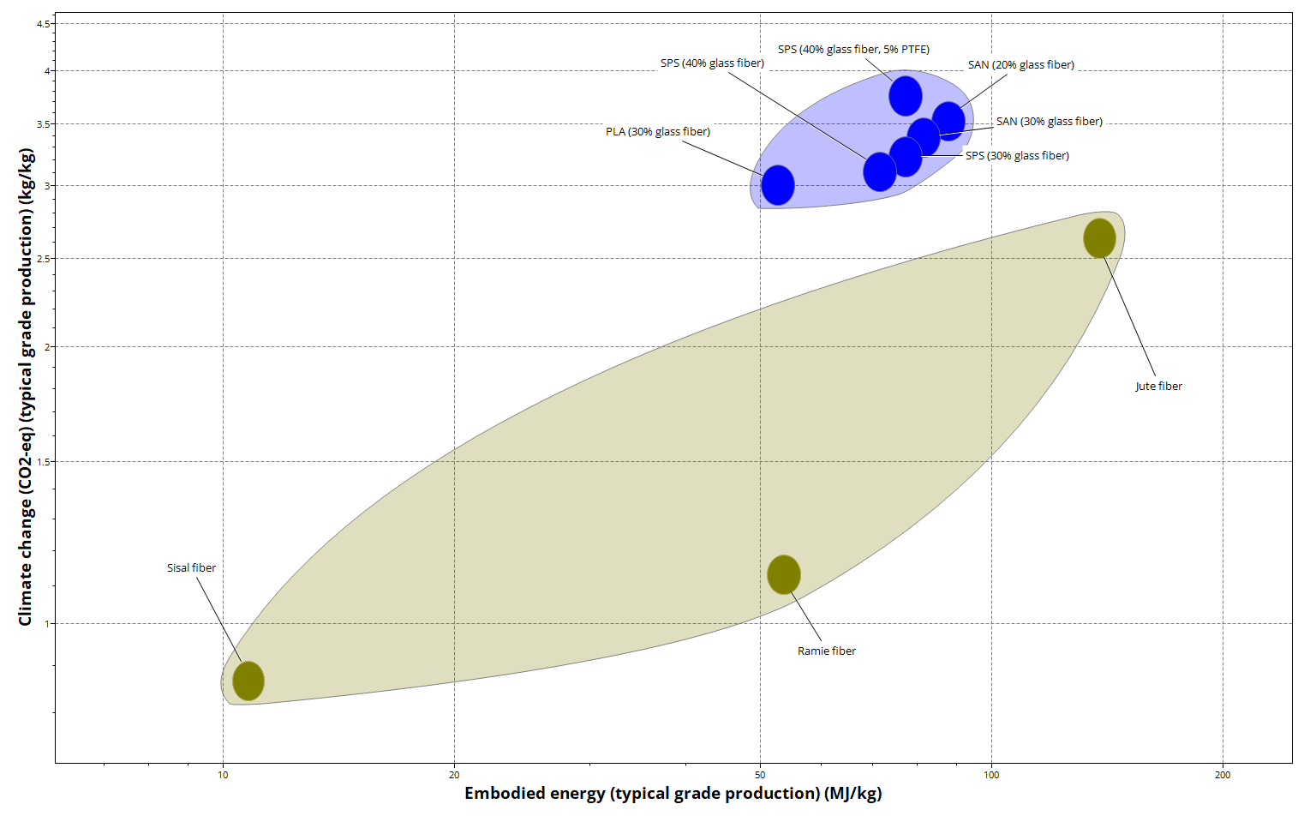
Fig. 4.2. EduPack embodied impact comparison for candidate fibres and reference polymer fibres (embodied energy and climate change indicators).
Natural fibres can reduce the embodied impacts and persistence risk of fossil fuels, but how well they work depends on the quality of the fibres and how sensitive they are to moisture. This led to the decision to use a braided cord construction and keep the ABS handle to keep strength and ease of manufacturing.

Process selection
Process selection was carried out using Granta EduPack to identify manufacturing routes that meet functional requirements at the stated production volume, and to support lower-emission manufacture through renewable electricity supply.

Handle process (ABS)
The wand handle is an ABS component typically produced by high-throughput polymer moulding. EduPack process selection indicates that injection moulding is suitable at large economic batch sizes and competitive unit cost, supporting its selection for production at 50,000 units.
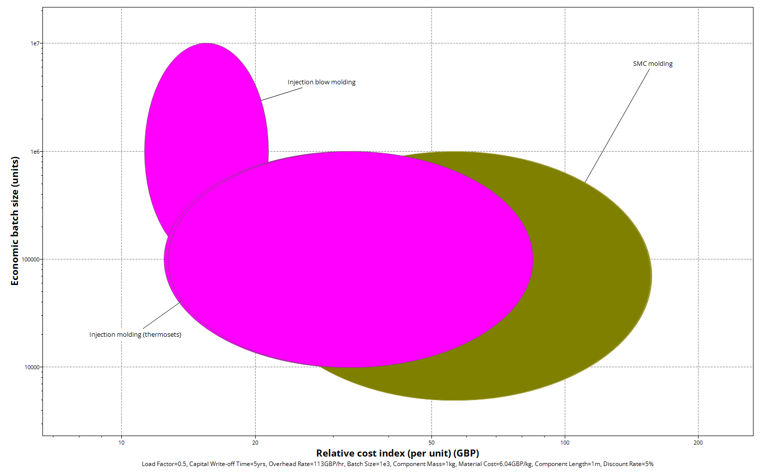
Fig. 4.3. EduPack process selection chart (relative cost index vs economic batch size) showing suitability of injection moulding at high production volumes.
A renewable electricity scenario was evaluated as a greener manufacturing option to reduce Scope-2 emissions associated with manufacturing energy demand. A simple multi-criteria decision matrix was also used to compare renewable electricity supply options for practicality and carbon reduction.

String process (braided hemp cord)
A process translation approach was used to link the string’s function and constraints to an appropriate low-emission manufacturing route. Given the flexible cord geometry, small mass, tolerance not being critical and high batch size (50,000 units), continuous processes such as spinning, twisting and braiding are appropriate. Braiding is preferred due to improved knot resistance, dimensional consistency and reduced fraying.
Category | Requirement / Input | Notes / Rationale
Component | String / cord (teaser-to-wand link) | Flexible link subjected to repeated bending and knotting
Function | Connect teaser to wand (flexible link for play) | Must withstand pulling, abrasion, and cyclic loading
Objectives | Minimize cost | High batch size (50,000) favors continuous production
 | Ensure biodegradability (eco-friendly) | Drives preference for natural fibers over synthetic fibers
Constraints – Material | Material class: Natural fiber (e.g., hemp, jute, cotton) | Selected to reduce fossil-derived content and persistence risk
Constraints – Process | Process class: Primary, continuous | Fibers are drawn/spun; continuous manufacture suits cords
Constraints – Shape | Shape class: Flexible cord | Long slender geometry; not suited to moulding/casting
Constraints – Mass | Very small mass per unit (approx. 0.01–0.05 kg) | String mass range compatible with textile processes
Constraints – Section size | Minimum thickness: ~1–3 mm diameter | Typical cord diameter range for pet toy strings
Constraints – Tolerance | Not critical (±0.5 mm acceptable) | Allows lower-cost manufacturing and broader process choice
Constraints – Production volume | Batch size: 50,000 units | Supports automated, continuous processes for efficiency
Free variables | Choice of process route: spinning, twisting, braiding | Evaluated against durability and consistency requirements
Selected process (output) | Braiding (after spinning/twisting as required) | Preferred for knot resistance, consistent diameter, reduced fraying
Table 4.1. Process translation table for the string component and selected process route (continuous manufacture; braided cord).

Renewable electricity options for lower-emission manufacture
A renewable electricity scenario was evaluated as a greener manufacturing option to reduce Scope-2 emissions associated with manufacturing energy demand. A simple multi-criteria decision matrix was used to compare renewable electricity supply options for practicality and carbon reduction.

Option | CAPEX | Speed of deployment | Emissions reduction potential | Practicality for a manufacturing site | Total
On-site solar PV | 3 | 4 | 4 | 4 | 15
Renewable tariff / certificate-backed supply | 5 | 5 | 3 | 5 | 18
Off-site PPA (e.g., wind/solar) | 4 | 3 | 5 | 3 | 15
Table 4.2. Multi-criteria decision matrix for renewable electricity supply options (1 = poor, 5 = excellent).
Critical analysis: Certificate-backed renewable procurement is fast and easy to use, while on-site PV generates power directly and visibly but needs space and money up front. A PPA can help with decarbonization in a significant amount, but it also makes contracts more complicated. These trade-offs inform implementation pathways depending on organisational constraints. Quantitative PV sizing and avoided-emissions calculations based on the Eco Audit manufacturing energy are presented in Section 4.5.1.

Product life cycle (PLC)
A PLC was developed to map stages where impacts occur and where design interventions are most effective. The PLC includes raw materials (ABS polymer and fibres), manufacturing of handle/string/attachment, distribution (China–UK sea freight assumption), use (no operational energy) and end-of-life (downcycling scenario in Eco Audit).
Fig. 4.4. Product life cycle diagram for the cat teaser wand (materials → manufacture → transport → use → end-of-life).
Critical analysis: Because the product has negligible use-phase energy, impacts are expected to be dominated by material production and manufacturing energy, making material substitution and electricity decarbonisation high-leverage strategies.

Life Cycle Analysis (Granta EduPack Eco Audit)

Eco Audit output (redesign case)
Eco Audit was conducted for the redesign configuration (ABS handle + hemp string + teaser attachment) using the assumptions defined in Chapter 3. The Eco Audit summary is used to report phase contributions and totals for first-life energy demand, climate change impact and cost.
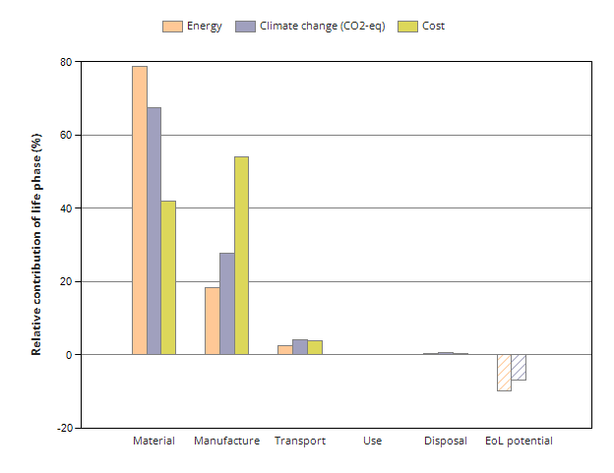
Fig. 4.5. Eco Audit summary output for the redesign case (ABS handle + hemp string + teaser attachment)
For the production batch the Eco Audit reports total first-life energy demand of 3.19×10^5 MJ and climate change impact of 1.46×10^4 kg CO2-eq with material and manufacturing phases dominating. Transport and disposal contribute marginally under the stated logistics and end-of-life assumptions. The end-of-life potential credit is reported as −3.16×10^4 MJ and −992 kg CO2-eq for the downcycling scenario.
Critical analysis: The dominance of the material phase indicates that embodied impacts (especially from polymer production and textile components) drive the life-cycle profile. The manufacturing contribution is also non-trivial, supporting the assessment of renewable electricity as an additional decarbonisation lever. End-of-life credits are sensitive to recovery assumptions and should be interpreted as potential rather than guaranteed real-world outcomes.

Eco Audit phase breakdown (redesign)
Phase | Energy (MJ) | Energy (%) | Climate change (CO2-eq) (kg) | Climate change (%) | Cost (GBP) | Cost (%)
Material | 2.51e+05 | 78.8 | 9.87e+03 | 67.4 | 4.73e+03 | 42.0
Manufacture | 5.83e+04 | 18.3 | 4.08e+03 | 27.9 | 6.08e+03 | 54.0
Transport | 7.85e+03 | 2.5 | 597 | 4.1 | 431 | 3.83
Use | 0 | 0.0 | 0 | 0.0 | 0 | 0.0
Disposal | 1.45e+03 | 0.5 | 102 | 0.7 | 15.8 | 0.14
Total (for first life) | 3.19e+05 | 100 | 1.46e+04 | 100 | 1.13e+04 | 100
End of life potential | −3.16e+04 | – | −992 | – | – | –
Table 4.3. Eco Audit summary for the redesign case (ABS handle + hemp string + teaser attachment).

Baseline vs redesign comparison (ABS + nylon vs ABS + hemp)
A baseline Eco Audit was conducted for the original configuration (ABS handle + nylon string + teaser attachment) and compared in EduPack against the redesign (ABS handle + hemp string + teaser attachment). The EduPack comparison output indicates that replacing the nylon string with hemp delivers an approximately 20% reduction in total first-life energy demand and an approximately 25% reduction in total climate-change impact (kg CO₂-eq) at the stated batch size, alongside a small cost reduction (~3%). The direction and scale of change are consistent with the material screening results (Section 4.1), where hemp shows lower embodied impact indicators than nylon within the EduPack database.
Critically, the improvement arises from a targeted substitution that changes only the string material while retaining the ABS handle and attachment, meaning the redesign avoids major manufacturability disruption yet still delivers measurable life-cycle benefits. However, the Eco Audit phase breakdown for the redesign (Table 4.2) shows that material production and manufacturing energy remain dominant contributors, implying that the achievable reduction from string substitution alone is bounded. This suggests that further reductions would require interventions in the remaining hotspots most plausibly (i) reducing ABS mass, (ii) redesigning the teaser attachment to reduce embodied impacts or improve separability and/or (iii) decarbonising manufacturing electricity (Section 4.5.1). Because the baseline totals were not retained for inclusion in this report, the comparison is presented using the relative change reported by EduPack, while the redesign totals and phase contributions are reported directly from the saved Eco Audit output.
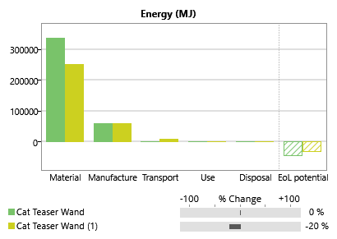

Fig. 4.6. Baseline vs redesign comparison chart showing percentage change in totals by Energy.
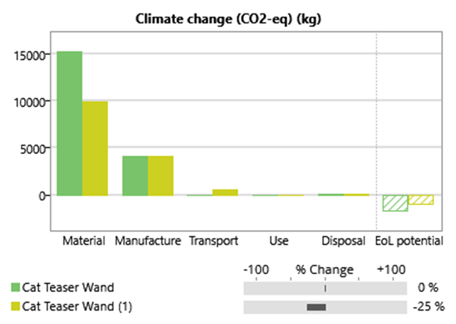
Fig. 4.7. Baseline vs redesign comparison chart showing percentage change in totals by Climate change.
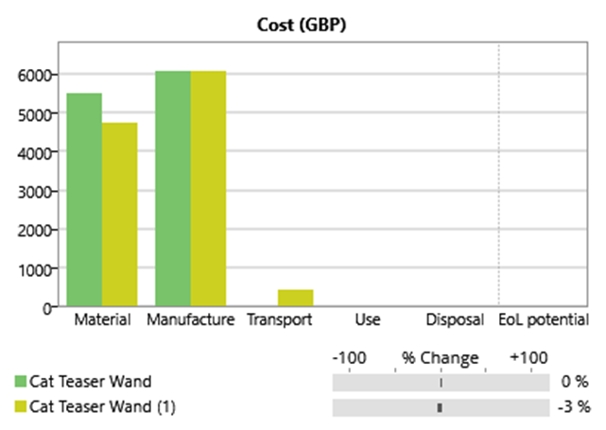
Fig. 4.7. Baseline vs redesign comparison chart showing percentage change in totals by Cost.

Metric | Baseline (ABS + nylon) derived | Redesign (ABS + hemp) | Change
Total energy (MJ) | 3.99e+05 | 3.19e+05 | −20%
Climate change (kg CO2-eq) | 1.95e+04 | 1.46e+04 | −25%
Cost (GBP) | 1.165e+04 | 1.13e+04 | −3%
Table 4.4. Baseline vs redesign totals (first life), batch of 50,000 (derived baseline).

Evaluation of proposal (sustainable development feasibility)

Economic feasibility and commercial risk
The redesign is commercially low-risk because it changes only the string material while retaining the ABS handle and overall product function. The derived totals indicate a small unit cost reduction at the stated batch size, suggesting that sustainability improvements do not require a cost premium in this case.
For manufacturing electricity decarbonisation, a solar PV option was assessed using the Eco Audit manufacturing energy demand as the basis for electricity sizing.

Parameter | Value
Manufacturing energy (MJ) | 5.83e+04
Manufacturing electricity (kWh) | 16,194 (MJ ÷ 3.6)
PV yield (kWh/kW-year) | 894 (10.2% × 8760)
PV capacity required (kW) | 18.1
PV installed cost (£/kW) | 1,256.23
Indicative PV CAPEX (£) | ~22,738
Grid factor (kg CO2e/kWh) | 0.20705
CO2e avoided (kg) | ~3,353
Table 4.5. Solar PV scenario for manufacturing electricity demand (batch of 50,000).
Critical analysis: PV feasibility depends on site constraints (roof/land area), load matching and electricity pricing. Where PV is impractical, renewable electricity procurement (tariff/certificates) provides a lower-barrier route to reduce Scope-2 emissions.

Environmental considerations
Eco Audit results indicate that the redesign reduces life-cycle energy and climate change impacts through a targeted substitution of nylon string with hemp cord. This reduces reliance on fossil-derived fibres and supports reduced persistent pollution risk associated with synthetic fibre shedding. The PV scenario cuts down on emissions even more during the manufacturing stage by replacing grid electricity which makes the carbon profile of that stage better. The proposed redesign aligns with policy objectives that call for extended product lifespans, enhanced circularity and reduced pollution from plastics and textiles (European Commission, 2022). The UK government's greenhouse gas conversion factors are used in the manufacturing electricity scenario to figure out how Scope-2 emissions will affect the environment. This is how standard reports are usually carried out (Department for Energy Security and Net Zero, 2025). Assumptions about the cost and performance of PV are based on UK data about the costs of renewable energy generation and technical parameters that support a decarbonization option that makes economic sense (Ove Arup & Partners Ltd, 2025). The life-cycle assessment approach and reporting assumptions follow established LCA standards and guidance on goal/scope definition, boundary setting and interpretation (ISO, 2006a; ISO, 2006b; European Commission Joint Research Centre, 2010).

H&S appraisal
The redesign introduces low additional safety risk but requires basic controls:
Cord integrity: specify minimum cord strength and abrasion resistance to prevent snapping and creation of loose parts.
Processing safety: natural fibres can produce dust during cutting/finishing; use local extraction and PPE as needed.
Electrical safety (PV): mitigate electrical shock/fire risk through compliant installation, isolation, inspection and maintenance.

Ethical considerations
Ethical considerations include responsible sourcing (labour conditions in fibre supply chains), credible environmental claims and reducing harm to ecosystems. The proposed redesign aligns with sustainable development by reducing life-cycle impacts and synthetic fibre pollution risk while maintaining product function and manufacturability.

Conclusions
Replacing the nylon string with hemp fibre cord reduces the cat teaser wand’s first-life energy demand by ~20% (3.99e+05 → 3.19e+05 MJ) and climate-change impact by ~25% (1.95e+04 → 1.46e+04 kg CO2-eq), with a ~3% cost reduction (1.165e+04 → 1.13e+04 GBP) at a batch size of 50,000.
The improvement is mainly driven by the lower embodied impacts of hemp fibre relative to nylon, while the ABS handle remains the dominant contributor to total impacts.
Eco Audit phase results indicate impacts are concentrated in material production and manufacturing, with transport and disposal contributing comparatively little under the stated assumptions.
A renewable electricity scenario indicates the manufacturing energy demand (5.83e+04 MJ ≈ 16,194 kWh) could be matched by an ~18.1 kW solar PV system, with an indicative CAPEX of ~£22,738 and avoided Scope-2 emissions of ~3,353 kg CO2e per batch using the stated UK grid factor.
Recommendations
Evaluate additional scenarios targeting the main hotspot: reduced ABS mass, recycled-content ABS, or alternative lower-impact polymers.
Assess redesign options for the teaser attachment (materials and separability) to improve circularity and reduce embodied impacts.
Validate the redesign through cord durability and safety testing (abrasion, knot strength, moisture effects) and refine labelling/recycling guidance to support better end-of-life outcomes.

References
Ahmed, A.T.M.F., Islam, M.Z., Mahmud, M.S., Sarker, M.E. and Islam, M.R. (2022) ‘Hemp as a potential raw material toward a sustainable world: A review’, Heliyon, 8(1), e08753. doi: 10.1016/j.heliyon.2022.e08753

Cheah, L., Duque Ciceri, N., Olivetti, E., Matsumura, S., Forterre, D., Roth, R. and Kirchain, R. (2013) ‘Manufacturing-focused emissions reductions in footwear production’, Journal of Cleaner Production, 44, pp. 18–29. doi: 10.1016/j.jclepro.2012.11.037

Department for Energy Security and Net Zero (2022) Feed-in Tariff load factor analysis: 2021/2022. Available at: https://assets.publishing.service.gov.uk/media/63a2dcc5e90e07586e7642bd/Feed-in_Tariff_load_factor_analysis_2021-22.pdf

Department for Energy Security and Net Zero (2025a) Greenhouse gas reporting: conversion factors 2025. Available at: https://www.gov.uk/government/publications/greenhouse-gas-reporting-conversion-factors-2025

Department for Energy Security and Net Zero (2025b) Solar photovoltaic (PV) cost data. Available at: https://www.gov.uk/government/statistics/solar-pv-cost-data

Department for Energy Security and Net Zero (2025c) Solar Costs 2024–25 (MS Excel spreadsheet). Available at: https://assets.publishing.service.gov.uk/media/6836cb303dd61280f46c041a/Solar_Costs_2024-25.xlsx

De Falco, F., Gullo, M.P., Gentile, G., Di Pace, E., Cocca, M., Gelabert, L., Brouta-Agnésa, M., Rovira, A., Escudero, R., Villalba, R., Mossotti, R., Montarsolo, A., Gavignano, S., Tonin, C. and Avella, M. (2018) ‘Evaluation of microplastic release caused by textile washing processes of synthetic fabrics’, Environmental Pollution, 236, pp. 916–925. doi: 10.1016/j.envpol.2017.10.057

De Falco, F., Di Pace, E., Cocca, M. and Avella, M. (2019) ‘The contribution of washing processes of synthetic clothes to microplastic pollution’, Scientific Reports, 9, 6633. doi: 10.1038/s41598-019-43023-x

European Commission (2022) EU Strategy for Sustainable and Circular Textiles (COM(2022)141 final). Available at: https://eur-lex.europa.eu/legal-content/EN/TXT/?uri=celex%3A52022DC0141

European Commission, Joint Research Centre (2010) ILCD Handbook: General guide for Life Cycle Assessment – Detailed guidance. Luxembourg: Publications Office of the European Union. Available at: https://eplca.jrc.ec.europa.eu/uploads/ILCD-Handbook-General-guide-for-LCA-DETAILED-GUIDANCE-12March2010-ISBN-fin-v1.0-EN.pdf

Formentini, G., Prioli, J.P.J., Ko, J., Hapuwatte, B., Ferrero, V., Badurdeen, F., Rickli, J.L. and Ramanujan, D. (2025) ‘A review of disassembly systems for circular product design’, Journal of Cleaner Production, 506, 145459. doi: 10.1016/j.jclepro.2025.145459

International Organization for Standardization (ISO) (2006a) ISO 14040:2006 Environmental management — Life cycle assessment — Principles and framework. Geneva: ISO.

International Organization for Standardization (ISO) (2006b) ISO 14044:2006 Environmental management — Life cycle assessment — Requirements and guidelines. Geneva: ISO.

Napper, I.E. and Thompson, R.C. (2016) ‘Release of synthetic microplastic plastic fibres from domestic washing machines: Effects of fabric type and washing conditions’, Marine Pollution Bulletin, 112(1–2), pp. 39–45. doi: 10.1016/j.marpolbul.2016.09.025

Ove Arup & Partners Limited (2025) Renewable Energy Generation Cost and Technical Assumptions 2024 – Onshore Wind and Solar PV: Cost of electricity report update 2024 (report for the Department for Energy Security and Net Zero). Available at: https://assets.publishing.service.gov.uk/media/68ba91f411b4ded2da19fe92/onshore-wind-and-solar-pv-cost-electricity-report-update-2024.pdf

Shahzad, A. (2012) ‘Hemp fiber and its composites – a review’, Journal of Composite Materials, 46(8), pp. 973–986. doi: 10.1177/0021998311413623

Thiriez, A. and Gutowski, T. (2006) An environmental analysis of injection molding. Cambridge, MA: Massachusetts Institute of Technology. Available at: https://web.mit.edu/ebm/www/Publications/Thiriez_ISEE_2006.pdf

Appendices

Appendix A: Eco Audit detailed outputs (redesign case)
Key Eco Audit detail pages used for the analysis are included below for traceability.
Eco Audit Report

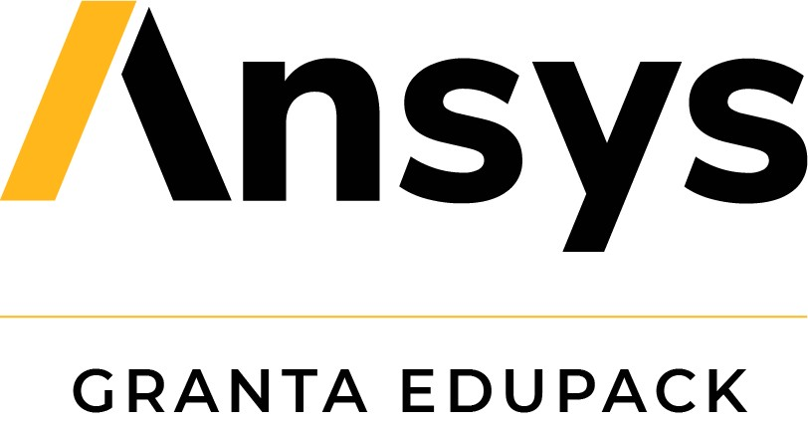
Summary

Energy Analysis

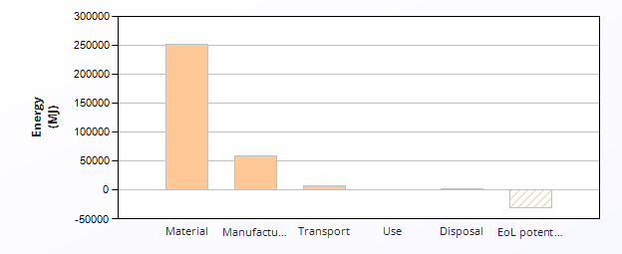
 | Energy (MJ/year)
Equivalent annual environmental burden (averaged over 1 year product life): | 3.19e+05

Detailed breakdown of individual life phases

Material: |  | Summary
Component | Material | Recycled content*  (%) | Part mass  (kg) | Qty. | Total mass processed**  (kg) | Energy  (MJ) | %
Wand (Handle) | ABS (medium-impact, injection molding) | Virgin (0%) | 0.05 | 50000 | 2.5e+03 | 2.4e+05 | 96.8
String | Hemp fiber | Virgin (0%) | 0.015 | 50000 | 7.5e+02 | 8.1e+03 | 3.2
Total |  |  |  | 100000 | 3.3e+03 | 2.5e+05 | 100

*Typical: Includes 'recycle fraction in current supply'

**Where applicable, includes material mass removed by secondary processes

***User-defined material

 | Manufacture: |  |  | Summary
Component | Process | % Removed | Amount processed |  | Energy  (MJ) | %
Wand (Handle) | Polymer molding (injection, blow) | - | 2.5e+03 | kg | 5.6e+04 | 96.7
String | Fabric production | - | 7.5e+02 | kg | 2e+03 | 3.3
String | Cutting and trimming | - | 0 | kg | 0 | 0.0
Total |  |  |  |  | 5.8e+04 | 100

Transport: |  |  | Summary
Breakdown by transport stage

Stage name | Transport type | Distance  (km) | Energy  (MJ) | %
China to UK | Sea, container ship | 1.8e+04 | 7.9e+03 | 100.0
Total |  | 1.8e+04 | 7.9e+03 | 100

Breakdown by components

Component | Mass  (kg) | Energy  (MJ) | %
Wand (Handle) | 2.5e+03 | 6e+03 | 76.9
String | 7.5e+02 | 1.8e+03 | 23.1
Total | 3.3e+03 | 7.9e+03 | 100

Use: |  |  |  | Summary
 | Relative contribution of static and mobile modes
Mode | Energy  (MJ) | %
Static | 0
Mobile | 0
Total | 0 | 100

Disposal: | Summary
Component | End of life option | % recovered | Energy  (MJ) | %
Wand (Handle) | Downcycle | 80.0 | 1.1e+03 | 75.7
String | Downcycle | 90.0 | 3.5e+02 | 24.3
Total |  |  | 1.5e+03 | 100

EoL potential:

Component | End of life option | % recovered | Energy  (MJ) | %
Wand (Handle) | Downcycle | 80.0 | -3.1e+04 | 99.8
String | Downcycle | 90.0 | -68 | 0.2
Total |  |  | -3.2e+04 | 100

Figure A1. Eco Audit energy analysis and material/manufacture breakdown for redesign case.

Eco Audit Report


Summary

Climate Change (CO2-eq) Analysis

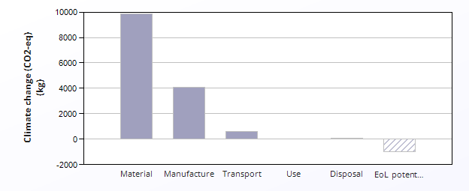
 | CO2 (kg/year)
Equivalent annual environmental burden (averaged over 1 year product life): | 1.46e+04

Detailed breakdown of individual life phases

Material: |  | Summary
Component | Material | Recycled content*  (%) | Part mass  (kg) | Qty. | Total mass processed**  (kg) | Climate change (CO2-eq)  (kg) | %
Wand (Handle) | ABS (medium-impact, injection molding) | Virgin (0%) | 0.05 | 50000 | 2.5e+03 | 9.2e+03 | 93.4
String | Hemp fiber | Virgin (0%) | 0.015 | 50000 | 7.5e+02 | 6.5e+02 | 6.6
Total |  |  |  | 100000 | 3.3e+03 | 9.9e+03 | 100

*Typical: Includes 'recycle fraction in current supply'

**Where applicable, includes material mass removed by secondary processes

***User-defined material

 | Manufacture: |  |  | Summary
Component | Process | % Removed | Amount processed |  | Climate change (CO2-eq)  (kg) | %
Wand (Handle) | Polymer molding (injection, blow) | - | 2.5e+03 | kg | 3.9e+03 | 96.2
String | Fabric production | - | 7.5e+02 | kg | 1.6e+02 | 3.8
String | Cutting and trimming | - | 0 | kg | 0 | 0.0
Total |  |  |  |  | 4.1e+03 | 100

Transport: |  |  | Summary
Breakdown by transport stage

Stage name | Transport type | Distance  (km) | Climate change (CO2-eq)  (kg) | %
China to UK | Sea, container ship | 1.8e+04 | 6e+02 | 100.0
Total |  | 1.8e+04 | 6e+02 | 100

Breakdown by components

Component | Mass  (kg) | Climate change (CO2-eq)  (kg) | %
Wand (Handle) | 2.5e+03 | 4.6e+02 | 76.9
String | 7.5e+02 | 1.4e+02 | 23.1
Total | 3.3e+03 | 6e+02 | 100

Use: |  |  |  | Summary
 | Relative contribution of static and mobile modes
Mode | Climate change (CO2-eq)  (kg) | %
Static | 0
Mobile | 0
Total | 0 | 100

Disposal: | Summary
Component | End of life option | % recovered | Climate change (CO2-eq)  (kg) | %
Wand (Handle) | Downcycle | 80.0 | 77 | 75.7
String | Downcycle | 90.0 | 25 | 24.3
Total |  |  | 1e+02 | 100

EoL potential:

Component | End of life option | % recovered | Climate change (CO2-eq)  (kg) | %
Wand (Handle) | Downcycle | 80.0 | -9.9e+02 | 99.5
String | Downcycle | 90.0 | -4.7 | 0.5
Total |  |  | -9.9e+02 | 100

Figure A2. Eco Audit climate change analysis and material breakdown for redesign case.

Eco Audit Report


Summary

Cost Analysis

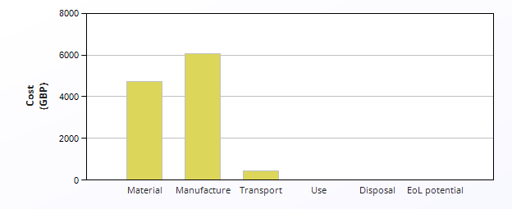
 | Cost (GBP/year)
Equivalent annual environmental burden (averaged over 1 year product life): | 1.13e+04

Detailed breakdown of individual life phases

Material: |  | Summary
Component | Material | Recycled content*  (%) | Part mass  (kg) | Qty. | Total mass processed**  (kg) | Cost  (GBP) | %
Wand (Handle) | ABS (medium-impact, injection molding) | Virgin (0%) | 0.05 | 50000 | 2.5e+03 | 4e+03 | 85.5
String | Hemp fiber | Virgin (0%) | 0.015 | 50000 | 7.5e+02 | 6.8e+02 | 14.5
Total |  |  |  | 100000 | 3.3e+03 | 4.7e+03 | 100

*Typical: Includes 'recycle fraction in current supply'

**Where applicable, includes material mass removed by secondary processes

***User-defined material

 | Manufacture: |  |  |  |  |  | Summary
Country of manufacture |  |  |  | The Whole World
Component | Process | Length (m) | % Removed | Amount processed |  | Cost  (GBP) | %
Wand (Handle) | Polymer molding (injection, blow) | - | - | 2.5e+03 | kg | 6.1e+03 | 100.0
String | Fabric production | - | - | 7.5e+02 | kg | 0 | 0.0
String | Cutting and trimming | - | - | 0 | kg | 0 | 0.0
Total |  |  |  |  |  | 6.1e+03 | 100

Transport: |  | Summary
Package dimensions

Height (m) | Width (m) | Depth (m)
1 | 0.03 | 0.02

Breakdown by transport stage

Stage name | Transport type | Distance  (km) | Cost  (GBP) | %
China to UK | Sea, container ship | 1.8e+04 | 4.3e+02 | 100.0
Total |  | 1.8e+04 | 4.3e+02 | 100

Breakdown by components

Component | Mass  (kg) | Cost  (GBP) | %
Wand (Handle) | 2.5e+03 | 3.3e+02 | 76.9
String | 7.5e+02 | 1e+02 | 23.1
Total | 3.3e+03 | 4.3e+02 | 100

Use: |  |  |  | Summary
 | Relative contribution of static and mobile modes
Mode | Cost  (GBP) | %
Static | 0
Mobile | 0
Total | 0 | 100

Disposal: | Summary
Component | End of life option | % recovered | Cost  (GBP) | %
Wand (Handle) | Downcycle | 80.0 | 12 | 76.9
String | Downcycle | 90.0 | 3.6 | 23.1
Total |  |  | 16 | 100

Figure A3. Eco Audit transport, use and disposal cost breakdown for redesign case.

